**Project Design Phase-II**

**Data Flow Diagram & User Stories**

|  |  |
| --- | --- |
| Date | 03 October 2022 |
| Team ID | PNT2022TMID35588 |
| Project Name | Project – A Novel Method for Handwritten Digit Recognition System |
| Maximum Marks | 4 Marks |

**Data Flow Diagrams:**

A Data Flow Diagram (DFD) is a traditional visual representation of the information flows within a system. A neat and clear DFD can depict the right amount of the system requirement graphically. It shows how data enters and leaves the system, what changes the information, and where data is stored.

Example: DFD Level 0 (Industry Standard)

**Example:** [**(Simplified)**](https://developer.ibm.com/patterns/visualize-unstructured-text/)

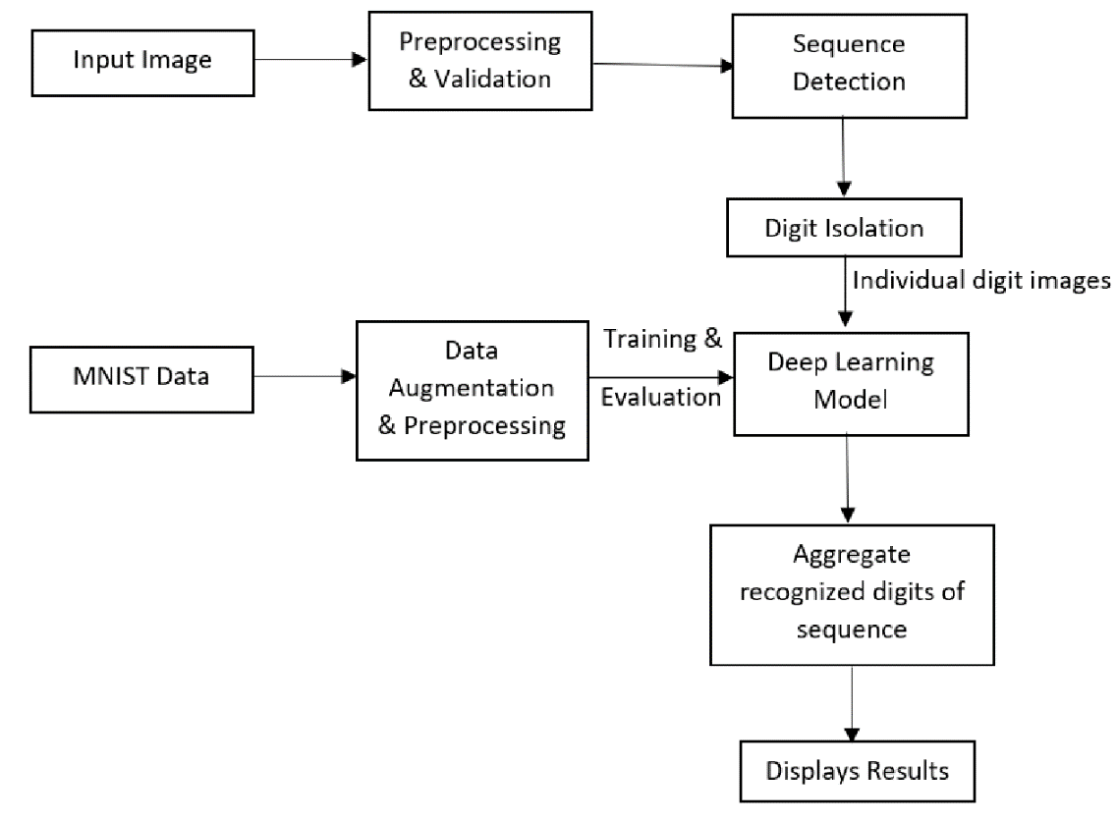

**](https://developer.ibm.com/patterns/visualize-unstructured-text/)**

**User Stories**

Use the below template to list all the user stories for the product.

|  |  |  |  |  |  |  |
| --- | --- | --- | --- | --- | --- | --- |
| **User Type** | **Functional**  **Requirement**  **(Epic)** | **User Story**  **Number** | **User Story / Task** | **Acceptance criteria** | **Priority** | **Release** |
| Customer  (Mobile user) | Registration | USN-1 | As a user, I can register for the application by entering my email, password, and confirming my password. | I can access my account / dashboard | High | Sprint-1 |
|  |  | USN-2 | As a user, I will receive confirmation email once I have registered for the application | I can receive confirmation email & click confirm | High | Sprint-1 |
|  |  | USN-3 | As a user, I can register for the application through Facebook | I can register & access the dashboard with Facebook Login | Low | Sprint-2 |
|  |  | USN-4 | As a user, I can register for the application through Gmail | I can register the application with Gmail | Medium | Sprint-2 |
|  | Login | USN-5 | As a user, I can log into the application by entering email & password | I can login to the application | High | Sprint-1 |
|  | Home | USN-6 | As a user, I can view the application’s home page where I can read the instructions to use this application | I can read instructions also and the home page is user-friendly. | Low | Sprint-1 |
|  | Upload Image | USN-7 | As a user, I can able to input the images of digital documents to the application | As a user, I can able to input the images of digital documents to the application | High | Sprint-3 |
|  | Predict | USN-8 | As a user I can able to get the recognised digit as output from the images of digital documents or images | I can access the recognized digits from  digital document or images | High | Sprint-3 |
|  |  | USN-9 | As a user, I will train and test the input to get the maximum accuracy of output. | I will be able to train and test the application until it gets maximum accuracy of the result. | Medium | Sprint-4 |
| Customer (Web user) | Accessibility | USN-10 | As a user, I can use the web application virtually anywhere. | I can use the application in any device with a browser | Medium | Sprint-4 |